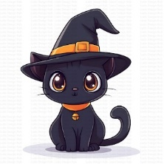
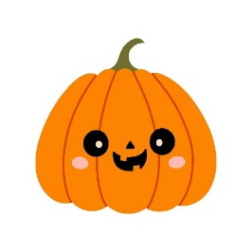
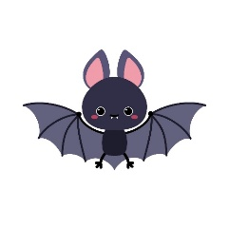
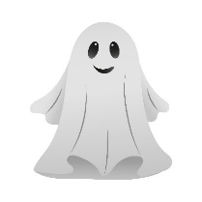
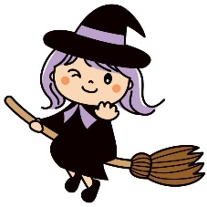
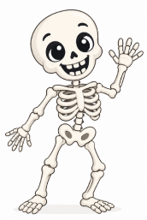
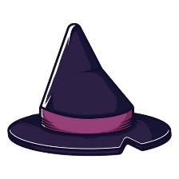
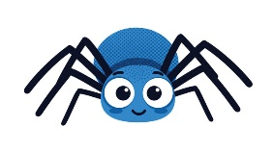
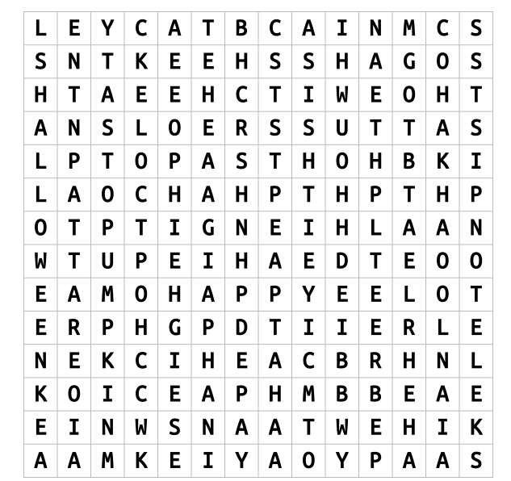
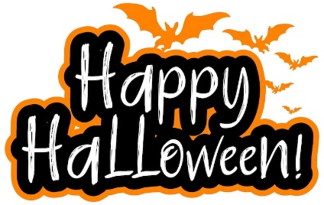
BAT
GHOST
CAT
PUMPKIN
WITCH
SKELETON
HAT
SPIDER
You can draw your favourite Halloween character.
(Můžeš nakreslit svou oblíbenou halloweenskou postavu)
Find the words in the word search:
(Najdi tato slova v osmisměrce): ghost, witch, skeleton, bat, pumpkin, cat, witch, skeleton spider, hat, happy, Halloween

