1 Work in pairs, discuss what u see in the picture, answer the questions below (10-15´)
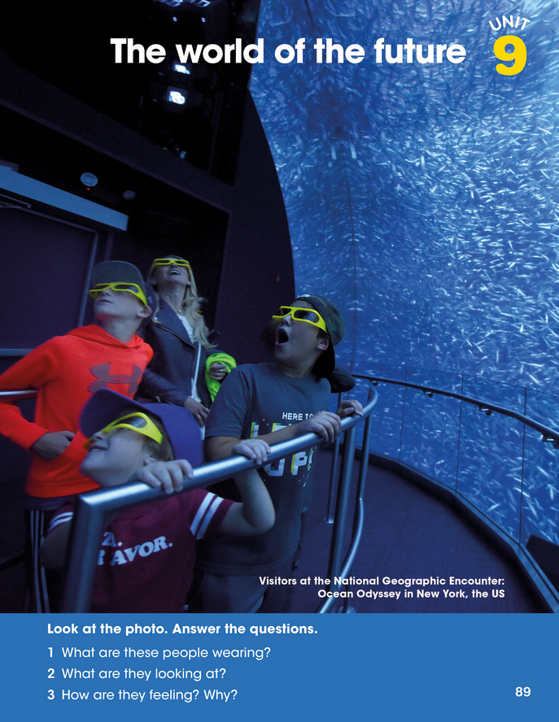

2) Excerxise 1 (listen+repeat). Ex. 2. Fill in, and check answers in pairs (then see solution) (15´)
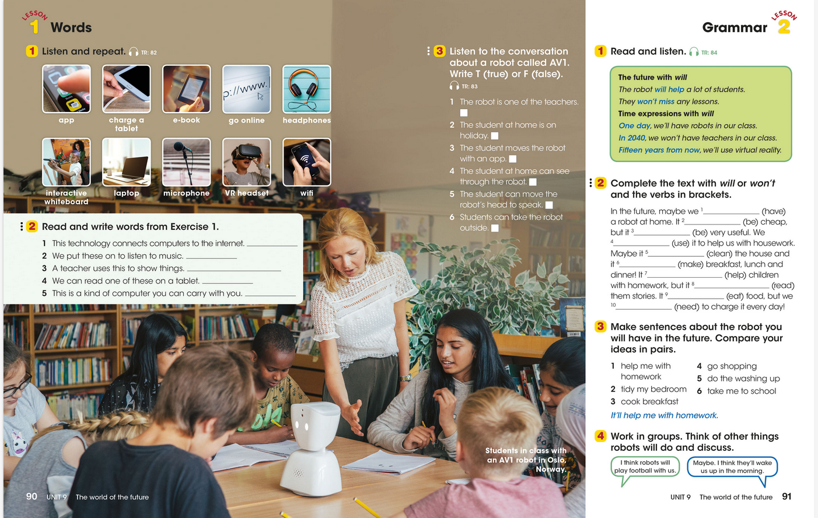
(3) Should you have some time left- do Ex. 1+2 in WB. (10´)
4) Review – what have you learned today?– (tgs I KNOW, didn´t KNOW, would like to KNOW MORE about, any questions I have … etc) (5´)

