Týdenní domácí úkol odevzdej do 30. 5. Jméno:

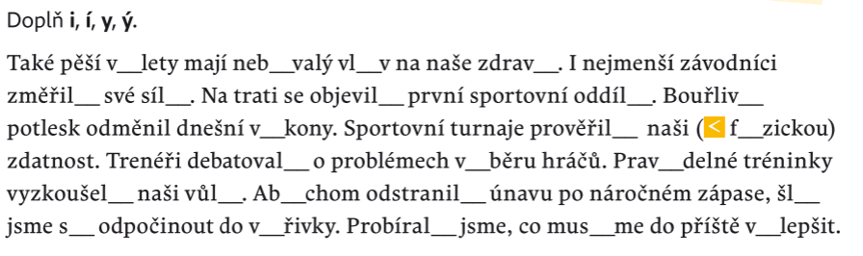
1)

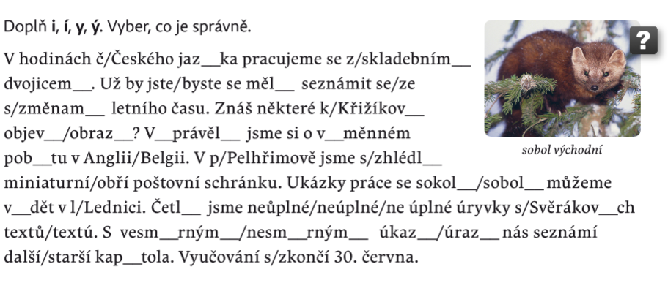
2)

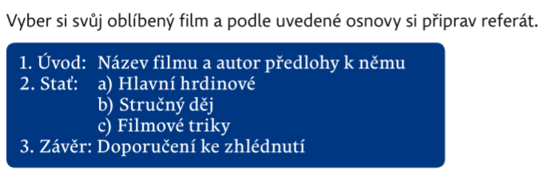
3)

_____________________________________________________________________________________________________________________________________________________________________________________________________________________________________________________________________________________________________________________________________________________________________________________________________________________________________________________________________________________________________________________________________________
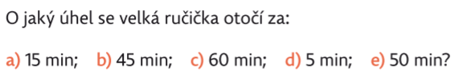
4)

5)

___________________________________________________________________________
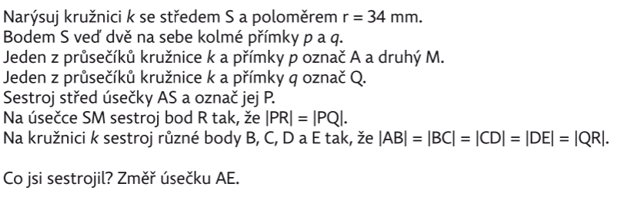
6)

