Týdenní domácí úkol odevzdej do 23. 5. Jméno:
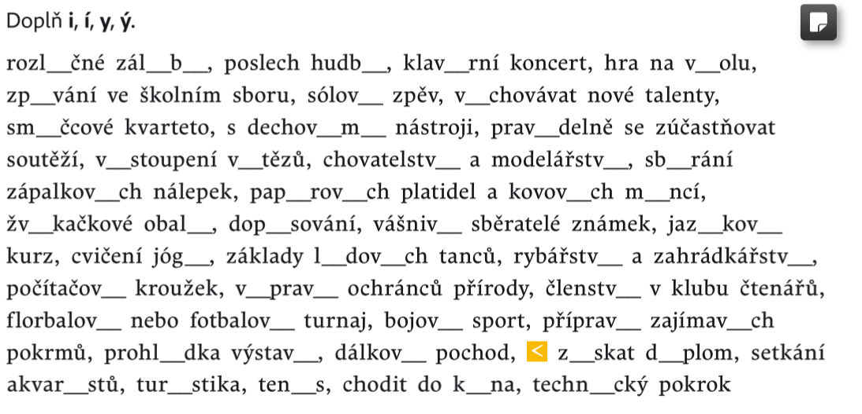
1)

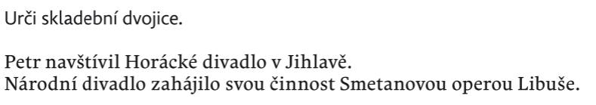
2)

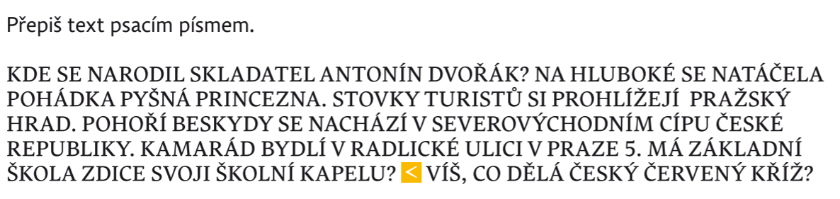
3)

___________________________________________________________________________________________________________________________________________________________________________________________________________________________________________________________________________________________________________________________________________________________________________________________________________________________________________________________________________________________________________________________________________________________________________________________________________________________________________________________________________________________________Odpověď na otázku: __________________________________________________________
4)
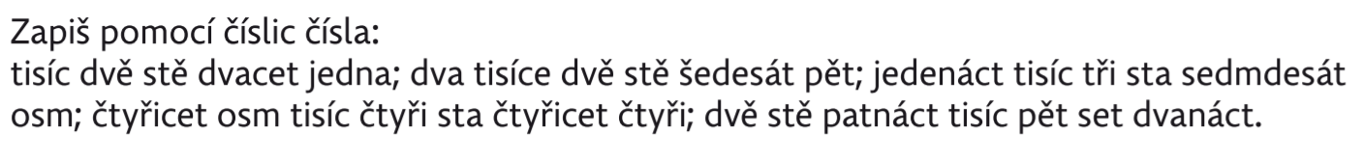

5)
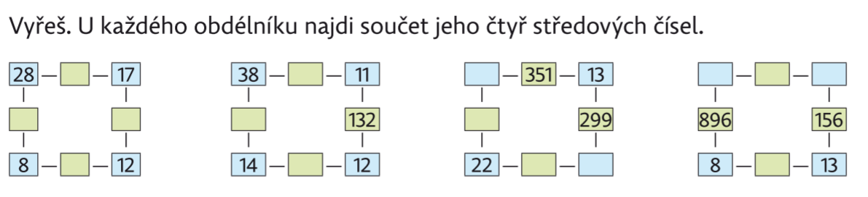

6)
