Units 1-3
1) Where is the monkey? It’s ____________.
2) Which letter is under the chair? _______
3)Which letter is on the clock? _______
4) How many fish are there? ____
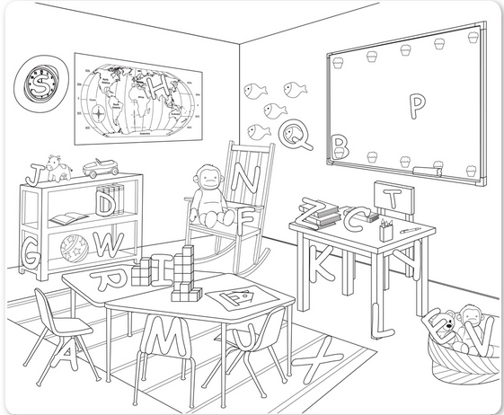
Units 4-6
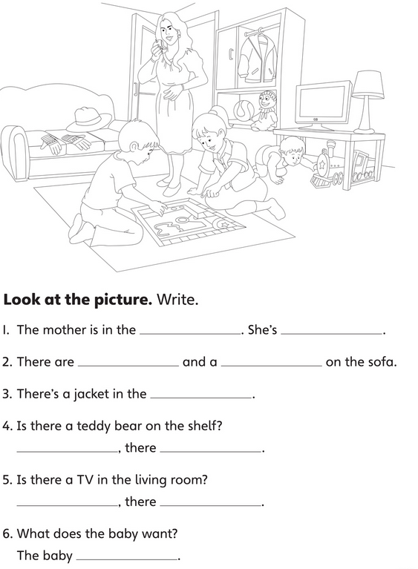
Units 7-9
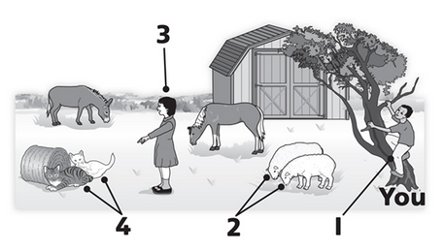
1. Can the boy climb? __________________
2. What are the sheep doing? ______________________________
3. What colour is the girl’s hair? ________________
4. How many cats are there? ___________________

