[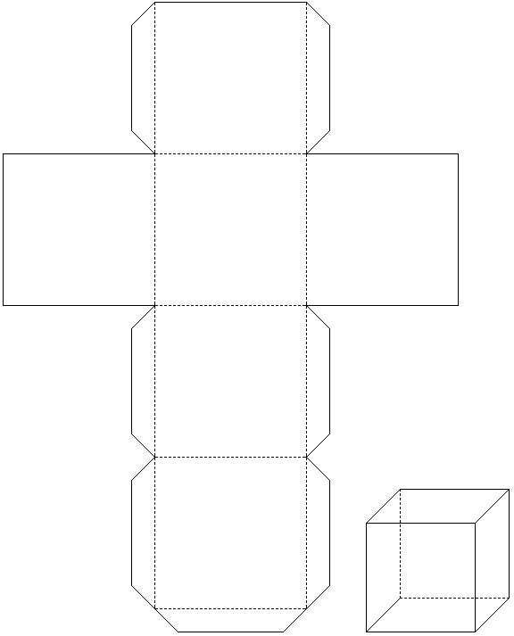](https://www.google.cz/url?sa=i&url=https://web.natur.cuni.cz/ugmnz/mineral/hry.html&psig=AOvVaw3zT5k_99Ph3YxvA6IRmyZI&ust=1584956632861000&source=images&cd=vfe&ved=0CAIQjRxqFwoTCMDT6fblregCFQAAAAAdAAAAABAN)

1 dm = 10 cm

KRYCHLE o hraně 1 dm

1dm = 10 cm